# Is Xanax legal in UK? Where Can You Buy Xanax Legally in the UK

Xanax can be obtained by private prescription only as [Xanax is not legal in uk](https://buyxanaxpillsnow.com/shop/buy-xanax-online-alprazolam)openly in general medical shops. If you want to buy Xanax in Uk you can buy it illegally or you can buy it from an online website available without prescriptions.

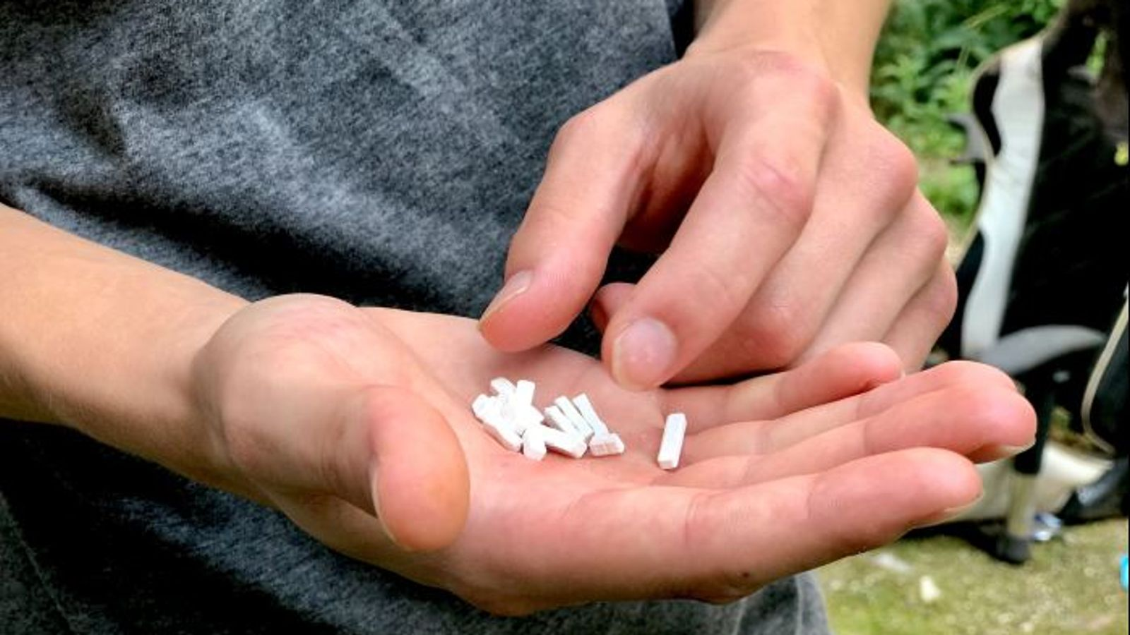

**What Does Xanax Look** – A small pills usually in oval shape but possible in other shapes. Xanax comes at different strengths in doses- 0.25 mg to 2 Mg and comes mostly in three colors white orange and pink.

**Why is Xanax Not Available On the NHS?** – Because it is licensed for short-term control from anxiety only. NHS has a variety of prescription-related drug benzodiazepines already. One can addict easily while using for a long time, and possibly fatal withdrawals

Where Can You Buy Xanax Legally in the UK?



As we all want to know [is xanax legal in uk](https://buyxanaxpillsnow.com/shop/buy-xanax-online-alprazolam)so prescription only as Xanax is not legal in the UK. But People in the UK use the online website to buy Xanax online in Uk. In the Uk, medicine is used to treat and cure anxiety but in us, it is available over the counter. However, NHS opened an investigation in the UK that people are buying Xanax illegally in the Uk And the investigation is still open on this.

**What is the side-effect of Xanax? –**Before using Xanax we all should know about the side effects of Xanax as someone can be addicted easily to buy this medicine. Here is some serious side-effect you may face after using this medicine.



Trouble breathing

Swelling in your hands or feet

Muscle weakness

Dry mouth

Blurred vision

Upset stomach

Nausea

Headache.